**Project 2 MATH5350**

CHUNG,Chak Pong.

20015116

**Problem**

Use Riemann solver to code Linearised gas dynamics equation

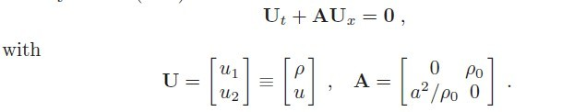

Finite volume scheme is used in this project:

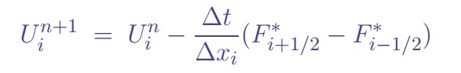

The flux F is A*U,where U is

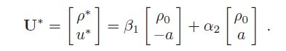

Where beta and alpha are given by

C:\Users\Administrator\Desktop\PROJ2\beta.jpg

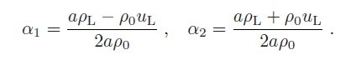

**Three different initial conditions**

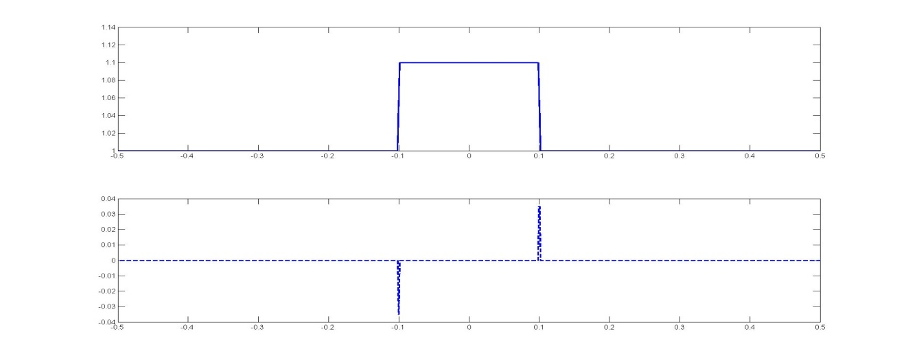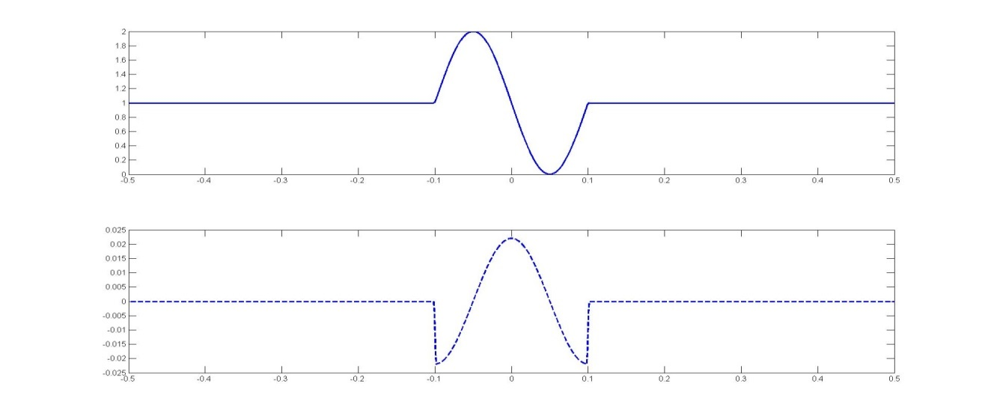

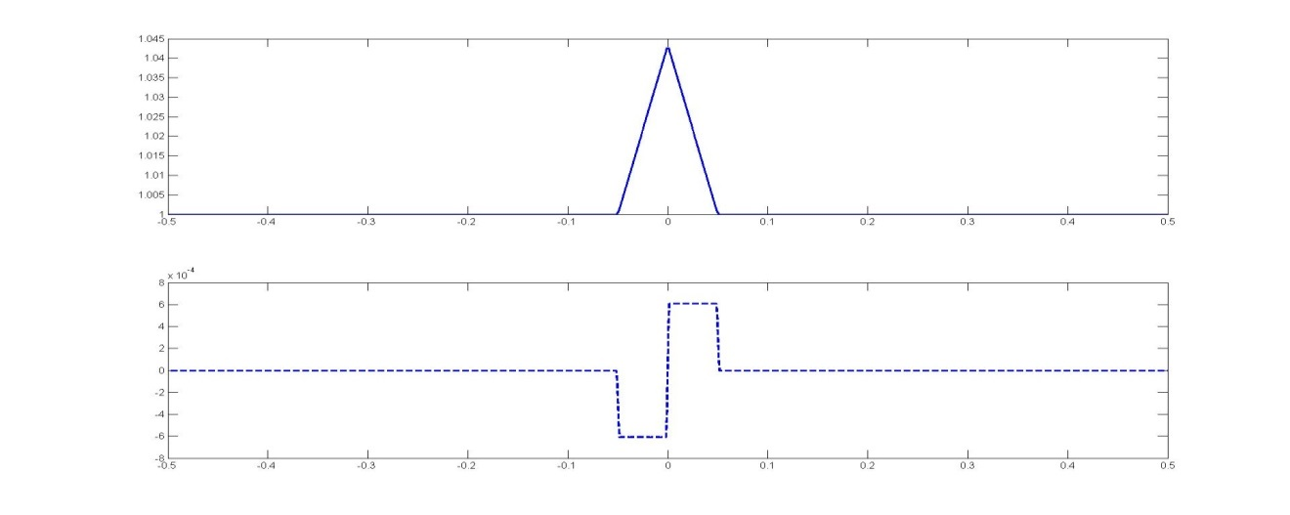

**Boundary condition**

The difference between **open boundary** and **reflection boundary** lies in the **two far end** of the grid. Only two ghost points are used for this Riemann solver used. But 4 ghost points will be used if the flux depends on neighboring four points. For open boundary, we need to copy the value of the point next to the ghost point to the ghost point. For reflection boundary, we can fill in the ghost point in a way that there is a wave coming in opposite direction.

**Sine**:

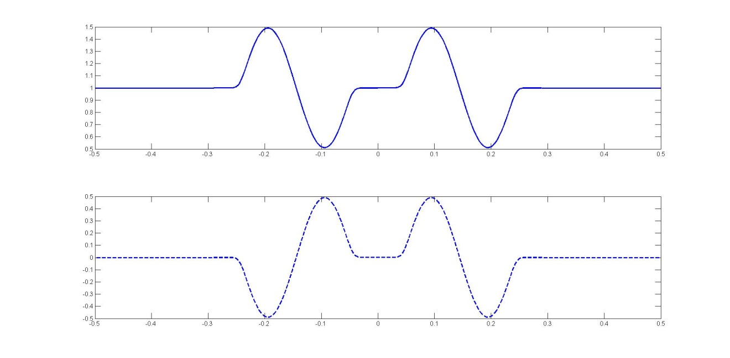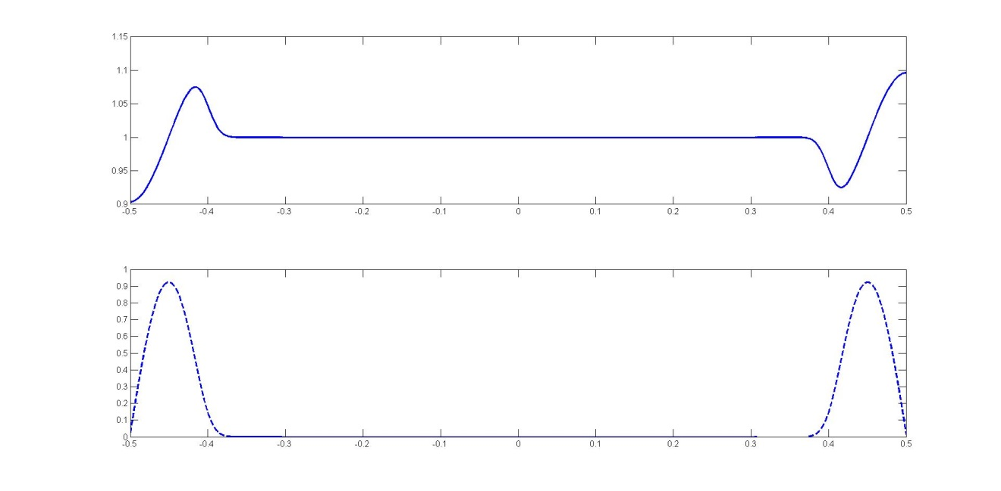

Reflection starts from here:

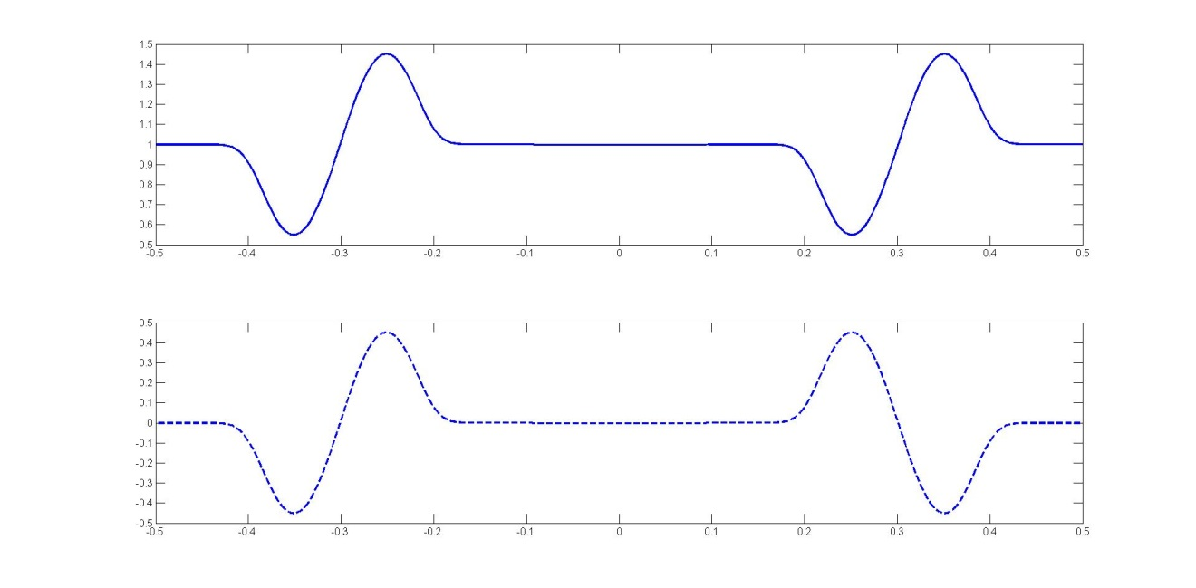

**Square** (spread into two half square gradually then moving to different end. Below is the graph when approaching to the end and then reflected.)

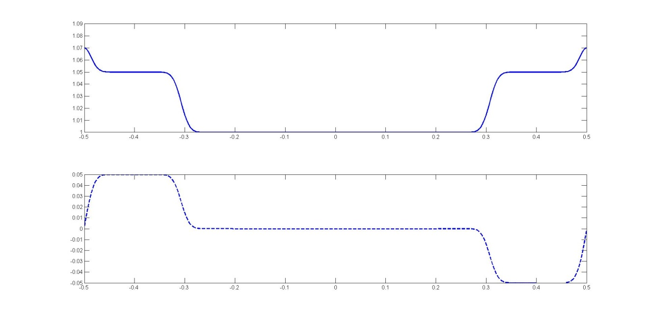

Reflection starts from here:

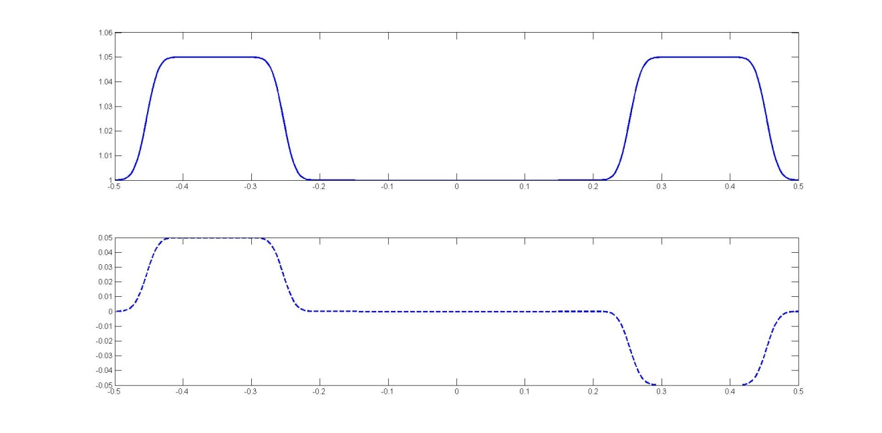

**Triangle**

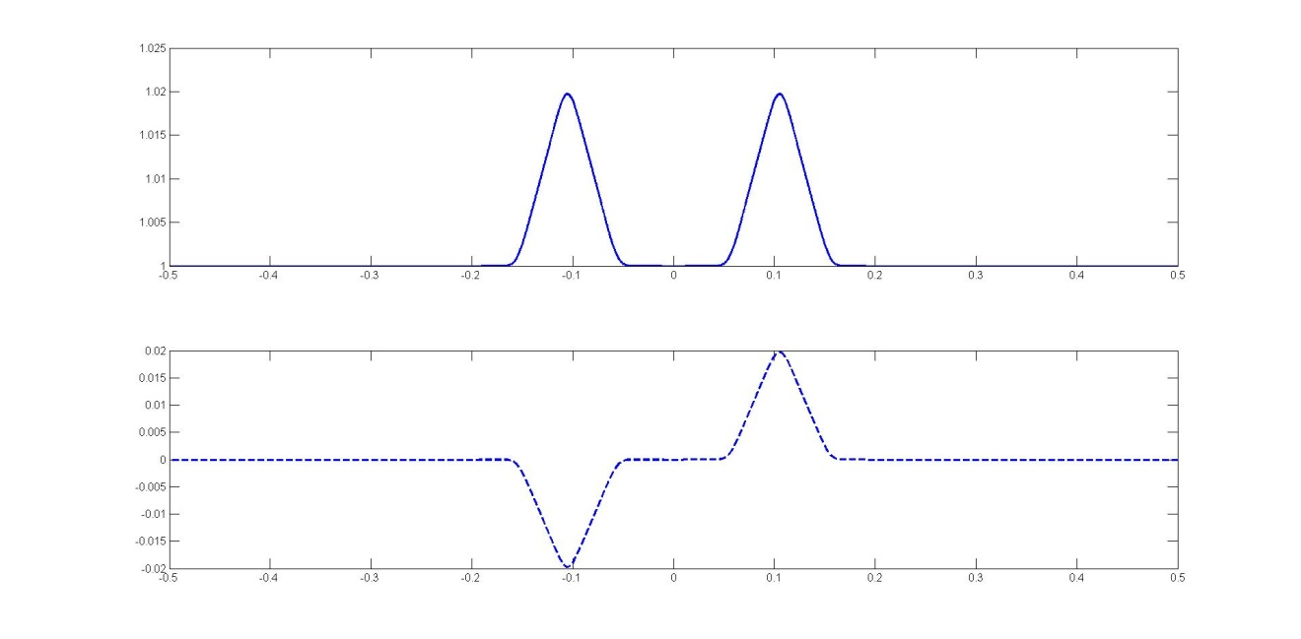Reflection starts from here:

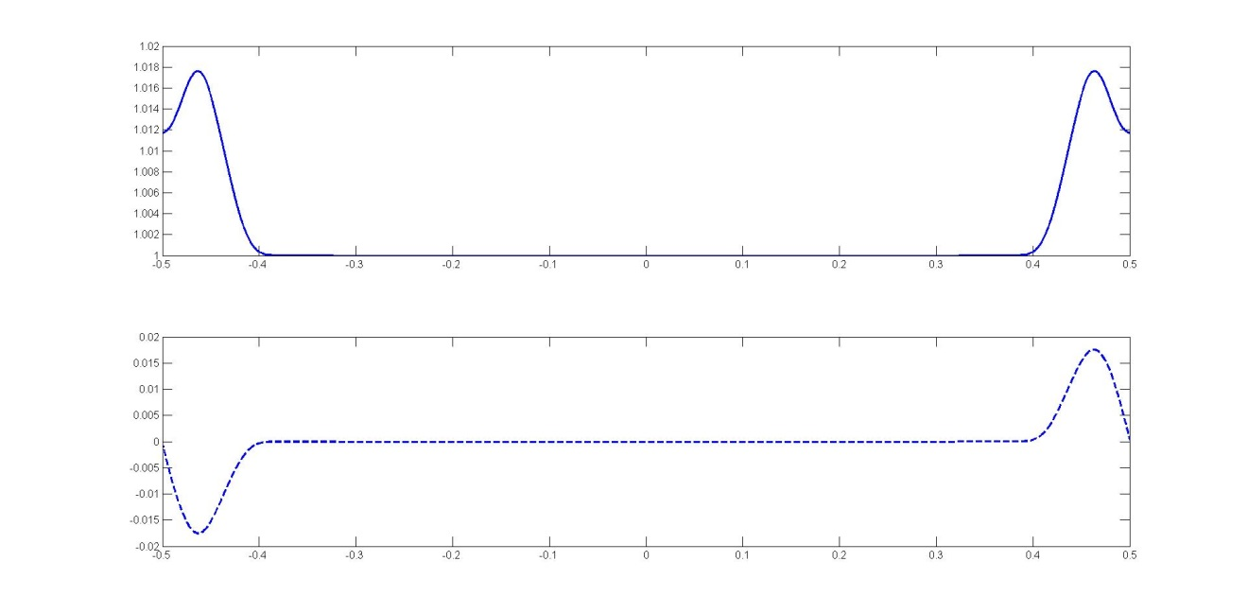

Reflection starts from here:

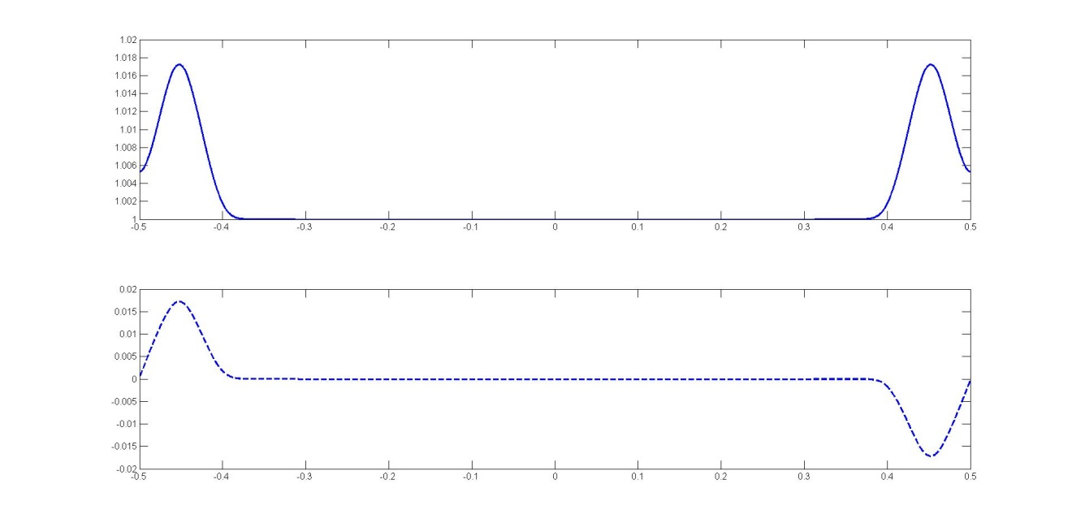

**Code**

The **FORTRAN code** is attached in the end

The subroutine for drawing the graph is commented out for easy reading of the main part.